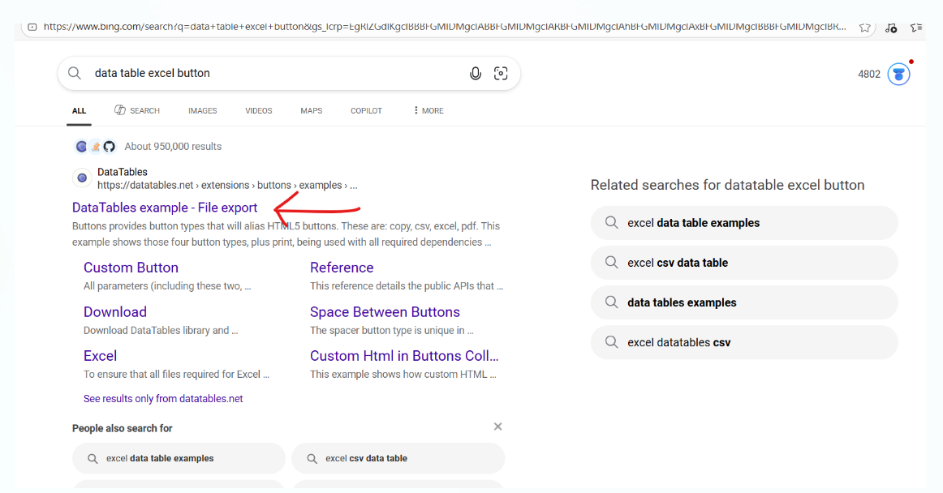

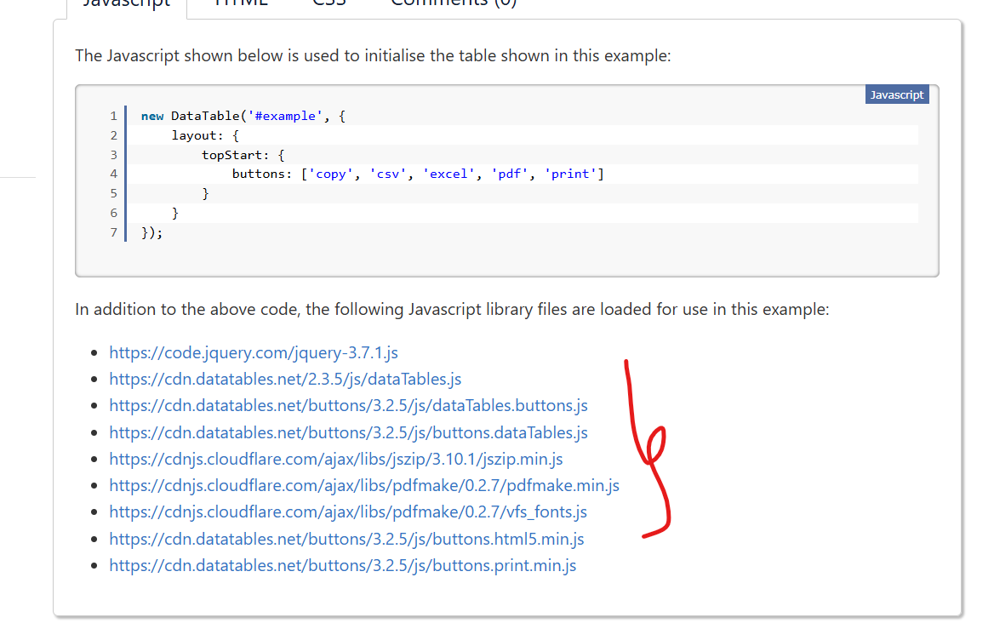

<!-- jQuery (luôn đứng đầu) -->
<script src="https://code.jquery.com/jquery-3.7.1.js"></script>

<!-- DataTables core -->
<script src="https://cdn.datatables.net/2.3.5/js/dataTables.js"></script>

<!-- Buttons extension -->
<script src="https://cdn.datatables.net/buttons/3.2.5/js/dataTables.buttons.js"></script>
<script src="https://cdn.datatables.net/buttons/3.2.5/js/buttons.dataTables.js"></script>

<!-- JSZip (export Excel cần) -->
<script src="https://cdnjs.cloudflare.com/ajax/libs/jszip/3.10.1/jszip.min.js"></script>

<!-- pdfmake (export PDF cần) -->
<script src="https://cdnjs.cloudflare.com/ajax/libs/pdfmake/0.2.7/pdfmake.min.js"></script>
<script src="https://cdnjs.cloudflare.com/ajax/libs/pdfmake/0.2.7/vfs_fonts.js"></script>

<!-- Buttons HTML5 + Print -->
<script src="https://cdn.datatables.net/buttons/3.2.5/js/buttons.html5.min.js"></script>
<script src="https://cdn.datatables.net/buttons/3.2.5/js/buttons.print.min.js"></script>

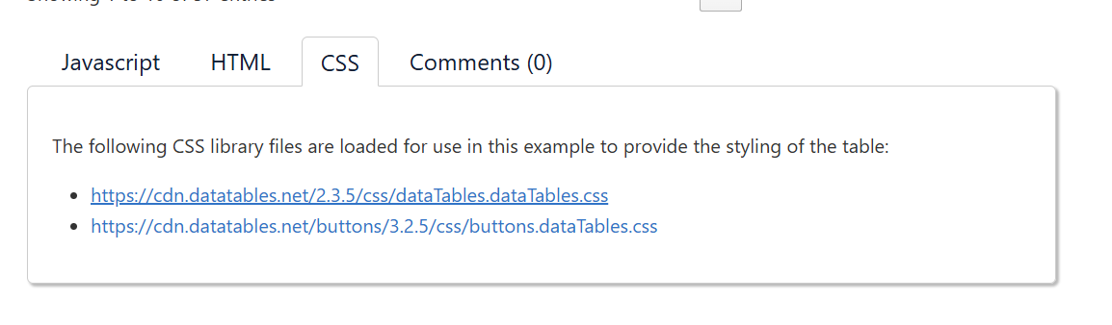
<link href="https://cdn.datatables.net/2.3.5/css/dataTables.dataTables.css " rel="stylesheet">
<link href="https://cdn.datatables.net/buttons/3.2.5/css/buttons.dataTables.css " rel="stylesheet">

Views
@model List<TechLaptop.Models.ProductModel>
<table class="table" id="myTable">
<thead>
<tr>
<th scope="col">#</th>
<th scope="col">Product Name</th>
<th scope="col">Product Description</th>
<th scope="col">Product Price</th>
<th scope="col">Product Image</th>
<th scope="col">Product Slug</th>
<th scope="col">Product Category</th>
<th scope="col">Product Brand</th>
<th scope="col">Product Manage</th>
</tr>
</thead>
<tbody>
<tr>
<td >#</td>
<td>@item.Name</td>
<td>@Html.Raw(@item.Description)</td>
<td>@item.Price.ToString("#,##0 VND")</td>
<td> <img src="~/media/products/@item.Image" alt="mô tả ảnh" width="190" height="130"> </td>
<td>@item.Slug</td>
<td>@item.Category.Name</td>
<td>@item.Brand.Name</td>
<td>
<a asp-action="Edit" asp-controller="Product" asp-route-Id="@item.Id" class="btn btn-warning btn-sm">Edit</a>
<a asp-action="Delete" asp-controller="Product" asp-route-Id="@item.Id" class="btn btn-danger btn-sm confirmDeletion">Delete</a>

</td>
</tr>
</tbody>
</table>

@section Scripts {
<script>
let table = new DataTable('#myTable', {
layout: {
topStart: {
buttons: ['copy', 'csv', 'excel', 'pdf', 'print']
}
}
});

</script>
}

